Medical Image Analysis Using Brain Tumor Detection

Dev Jethva

*Department of Computer Science and Engineering, School of Technology,*

*Pandit Deendayal Energy University,*

Gandhinagar, Gujarat, India Email: [devjethva235@icloud.com](mailto:devjethva235@icloud.com)

***Abstract*—Recognizing brain tumors is fundamental for giving successful treatment to patients. This inquire about examined how MRI checks and profound learning calculations can be utilized to classify brain cancers. Seven models were evaluated: VGG16, CNN, DenseNet-121, ResNet-50, MobileNetV2, VGG19, and EfficientNetB0. The dataset consisted of over 7000 MRI images categorized into four tumor types and a non-tumor class. VGG16, DenseNet-121, MobileNetV2, and VGG19 achieved high accuracy on the test dataset, demonstrating deep learning’s potential for brain tumor classification. While ResNet-50 showed moderate accuracy, EfficientNetB0 required further exploration due to its lower performance. These findings spotlight the promise of deep mastering on this domain. Future studies ought to attention on hyperparameter tuning, combining fashions and incorporating extra statistics modalities for better accuracy. However, rigorous scientific validation is needed earlier than real- international deployment.**

# Introduction

Artificial intelligence (AI) era has been a first-rate issue withinside the current fast transformation of the healthcare enterprise introduced approximately through era improvements. Artificial Intelligence (AI) refers to a laptop computer that can simulate human intelligence and has numerous medical uses. The combat towards mind tumors is one such area. In the sector of medicine, mind tumors constitute a tremendous public fitness concern, and right analysis, remedy, and follow- up techniques are essential. AI has risen as a key gadget for fortifying the ones techniques and holds great measured guarantee for the early discovery and oversee of considerations tumors.

The presence of brain tumors impacts human well-being. By combining technology like huge facts analytics, system learning, and deep learning, synthetic intelligence (AI) is supposed to help withinside the analysis and remedy of complicated sicknesses like mind tumors. Through the evaluation of mind imaging strategies like Magnetic Resonance Imaging (MRI), AI is capable of pick out and categorize tumors. The vicinity, class, size, and aggressiveness of tumors can all be ascertained with the useful resource of AI algorithms. In addition to supporting sufferers apprehend their fitness better, this assists docs in presenting an analysis and remedy plan this is extra accurate [1].

There are 4 forms of thoughts tumor photographs like: Gliomas, Meningiomas, Pituitary and No tumor images. Gliomas constitute a various institution of mind tumors with various prognoses and remedy options. Early detection and a multidisciplinary technique to remedy are important for enhancing effects and nice of lifestyles for sufferers with gliomas. Ongoing studies and improvements in clinical era hold to offer new insights and treatment options for coping with this tough institution of mind tumors. One kind of brain tumor called a meningioma starts in the meninges, which are membranes that encircle the brain and spinal cord and serve as a barrier. Primary brain tumors of this type are the most frequently occurring, making up around one-third of all brain tumors. Meningiomas are normally slow-developing and regularly benign, even though a few may be malignant. Located near the base of the skull, the pituitary gland is often known as the” master gland” as it produces hormones that regulate various glands and biological functions. Sometimes, tumors can grow in this gland, and these are called pituitary tumors. No Tumor image does not contain any type of tumor

i.e. there is no brain tumor in the image.

Recently, different approaches have been developed for the automated detection of brain tumors, classified into Machine Learning (ML) and Deep Learning (DL) approaches according to feature selection, inclusion criteria, and the learning methodology. Within the framework of machine learning techniques, Classification greatly depends on the processes of feature extraction and feature selection [2][3]. Nonetheless, deep learning techniques are currently evaluating data by extracting information from images through advanced deep learning methods. In particular, CNNs offer precise results and are widely employed in analyzing medical images such as MRI scans [4][5][6]. Compared to traditional ML techniques, the main drawbacks are the requirement for a substantial training dataset and high computational complexity. Furthermore, selecting the appropriate deep learning model can be challenging since it requires an understanding of various factors, training techniques, and architectural design. Various Deep Leaning- mainly build upon absolute fashions were applied for mind tumor detection, namely VGG-16, VGG19, CNN, RESNET

-100, AlexNet, EfcientNetB4, InceptionV3 and etc.

# Literature Review

MRI imaging is actively utilized in modern scientific techniques to diagnose mind cancer. This phase thoroughly investigates the recognition of excellence in detecting and categorizing brain tumors. Recently, numerous researchers have focused on detecting, segmenting, and Classifying brain tumors. The significance of this topic continues to be prevalent in the medical field. The research outlines strategies for detecting brain tumors, employing both generative and dis- criminative techniques to differentiate between various brain images. Deep-learning algorithms have been employed for the diagnosis of brain tumors. Scholars have dedicated their efforts, and by using advanced computing technology, they have achieved improved accuracy.

Maqsood et al. [7] Created a method to detect brain tumors by combining Fuzzy logic integrated with the U-NET convolutional neural network architecture. The first step in the processing involves enhancing the contrast. followed by the utilization of Using fuzzy logic, edge detection is performed to detect edges in the enhanced images. Highlights are made from decayed sub-band pictures by applying a double tree-complex wavelet change at distinctive scales. The U-NET CNN is utilized to differentiate between brain images of meningioma and non-meningioma, effectively classifying these characteristics. This technique surpassed various new algorithms, achieving a precision level of 98.59%.

Togacar et al. [8] the brainMRNet network, as developed by utilizes the modulo and hyper column techniques. Before reaching the convolutional layer, the initial images are processed beforehand and then sent through the attention module, which identifies important areas and channels in the image. The hyper column approach used in the convolutional layers of BrainMRNet preserves features from each layer within the array structure of the final layer. This approach achieved a 96.05% rate of accuracy. Sajjad et al. [9] introduced a method utilizing CNN technology for the detection and classification of brain tumors. The approach involves utilizing a Cascade CNN algorithm to segment tumors and a VGG19 model for classification purposes. Prastawa et al. [10] differentiate tumor regions in brain MRIs by detecting edge pixels. This approach primarily identifies the uneven edges of the tumor area but does not effectively define the inner limit of the tumor region. Swati et al. [11] employed a VGG19 model pre-trained in contrast-enhanced MRI(CE-MRI) and fine-tuned it, resulting in an average accuracy of 94.82%. Kumar et al. [12] Utilized the ResNet50 CNN model and global average pooling in a brain tumor method to address overfitting, achieving an average accuracy of 97.48%. Anaraki et al. [13] proposed a technique utilizing CNN and GA to classify various Glioma images based on MRI information. GA was employed in the suggested system to automatically choose the CNN architecture. They achieved a predictive accuracy of 90.9% when identifying three different types of Glioma images. Additionally, the research yielded a 94.2% accuracy in differentiating between Glioma, Meningioma, and Pituitary tumors.

Gumaei et al. [14] proposed a mixed approach to extract characteristics for categorizing brain tumors by using a RELM for regularization purposes. The first step involves using min-max normalization, The PCA-NGIST hybrid method is applied to extract features, and then the RELM strategy is implemented. This artwork has an accuracy rate of 94.23%. Swati et al. [15] employed a pre-trained VGG19 model that was fine-tuned on contrast-enhanced MRI (CE-MRI) to enhance performance, achieving an average accuracy of 94.82%. Ku- mar et al. [16] created a technique for identifying brain tumors by leveraging the ResNet50 CNN model and global average pooling to address overfitting, yielding an average accuracy rate of 97.48%.

TABLE I

**Thorough overviews of latest research on identifying and categorizing brain tumors**

|  |  |  |  |
| --- | --- | --- | --- |
| **Reference** | **Methodology** | **Algorithms** | **Accuracy (%)** |
| Maqsood et al. [7] | Brain tumor detection method | Fuzzy logic, U-  NET CNN | 98.59% |
| Togacar et al. [8] | BrainMRNet net-  work | BrainMRNet  model | 96.5% |
| Sajjad et al. [9] | Brain tumor detection and classification | Cascade CNN  and VGG19 | 94.58% |
| Prastawa et al. [10] | BrainMRI | Geometric  and Spatial Constraints | 88.17% |
| Swati et al. [11] | Fine-tuned  VGG19 | Fine-tuned  VGG19 | 94.82% |
| Kumar et al. [12] | Brain tumor  method | ResNet50 CNN  Model | 97.48% |
| Anaraki et al. [13] | Brain tumor  method | CNN, Genetic Algorithm | 90.9% |
| Gumaei et al. [14] | Brain tumor classification | PCA-NGIST and  RELM | 94.23% |
| Swati et al. [15] | Brain tumor | fine-tuned  VGG19 | 94.82% |
| Kumar et al. [16] | Brain tumor  method | ResNet50 and  Global Average Pooling | 97.48% |

# Methodology

In this paper, I have to use four classes: a). Gliomas tumor,

1. Meningioma tumor, c). Pituitary tumor, d). No tumor

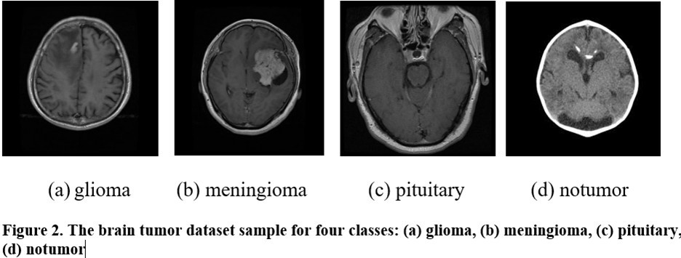

## Data Preprocessing

The process of deep learning involves multiple steps: preparing data (including cleaning, normalization, encoding), dividing it into training and testing sets, and designing the model structure. The model’s parameters are adjusted during training to reduce a loss function, and are later evaluated

using criteria like accuracy, precision, and recall. If the results are not good, you can modify the hyperparameters and redo the training. After achieving good performance, the model is able to provide predictions for unfamiliar data.

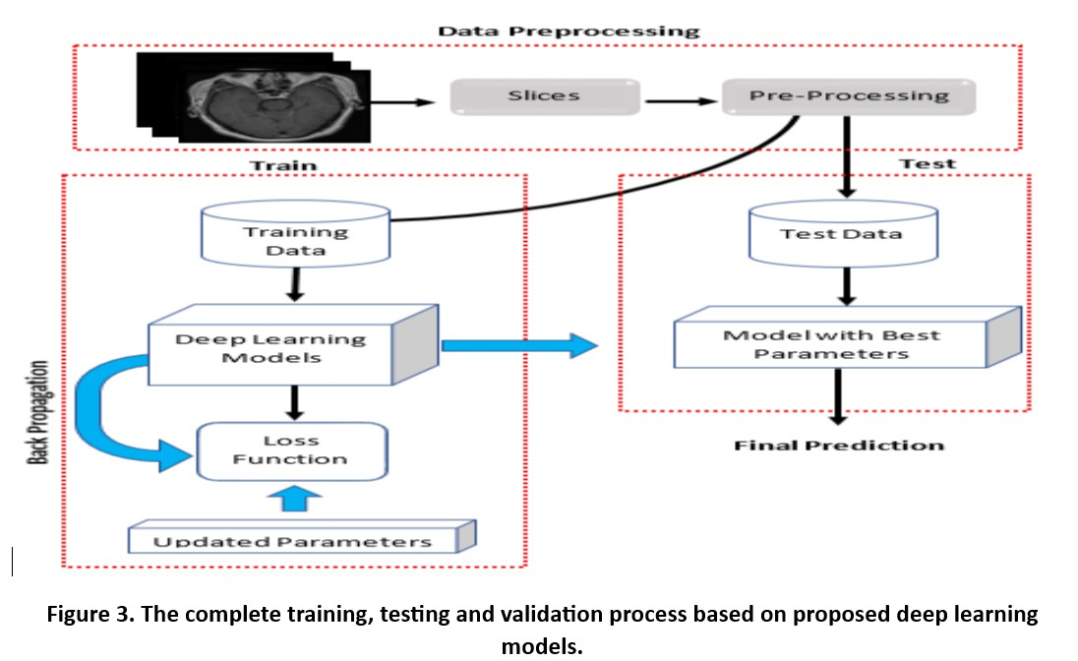

## Dataset Used

The dataset of brain images consists of 7023 MRI scans of the human brain, classified into 4 groups: meningioma, glioma, pituitary, and no-tumor. The pictures categorized as no-tumor were obtained from the Br35H dataset. Figure 2 displays a selection of four different brain tumor samples.

## Proposed Method Used

* + 1. ***VGG16****:* VGG 16 is a popular CNN model consisting of 16 layers known for its high effectiveness and straightforward design, utilizing ConvNet layers with a 3 × 3 kernel size. Its pre-existing values can be accessed for free on the internet. The model needs images to be at least 224 × 224 pixels in size and have three channels. Optimization algorithms in neural networks evaluate the involvement of neurons by computing the weighted sum of inputs. Kernel functions add non-linear characteristics to the output neuron. Neurons work with weights, biases, and training procedures, adjusting link weights based on output inaccuracy. Activation functions in the input layer introduce non-linear properties, allowing the network to grasp intricate tasks. Figure 4 presented a VGG 16 model architecture [14].

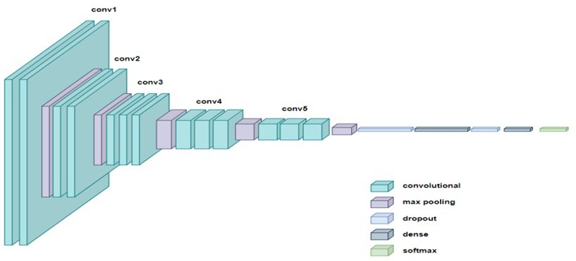

Figure 4. Example of VGG 16 model architecture

* + 1. ***Convolutional Neural Network****:* CNNs are a deep learning model known for their proficiency in handling image- related tasks. They are designed to automatically learn and

adjust spatial hierarchies of features from input images. A common CNN is composed of several layers, such as convolutional layers which extract features like edges, textures, and patterns using filters, pooling layers which decrease the size of feature maps to prevent overfitting and reduce computational workload, and fully connected layers which make final classifications using the extracted features. CNNs leverage local connectivity, weight sharing, and hierarchical learning to perform well in image classification, object detection, and seg- mentation tasks, making them essential for modern computer vision and AI applications. Figure 5 displays a Convolutional neural network architecture [15].

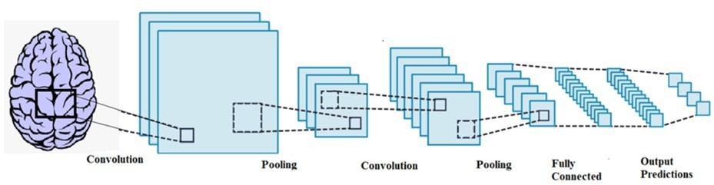

Figure 5. Example of CNN model architecture

* + 1. ***DenseNet-121 Model****:* DenseNet-121 is a Convolutional Neural Network known for its dense connectivity, enhancing information flow and mitigating the vanishing- gradient problem. It is made up of several compact blocks, with each layer getting input from all the layers before it, resulting in improved feature sharing and smoother gradient propagation. The design consists of a starting convolutional layer, then max pooling, dense blocks featuring bottleneck layers, and transition layers with 1x1 convolutions and average pooling. Average global pooling is applied to feature maps following the last dense block, this results in specific values that are then inputted into a layer that is fully connected and uses SoftMax activation for categorization. DenseNet-121 is parameter-efficient and excels in image classification tasks, trained using backpropagation and optimizers like Adam or SGD, by evaluating results on a test set using measurements like accuracy, precision, recall, and F1-score. Figure 6 showed the architectural design of a DenseNet-121 model [16].

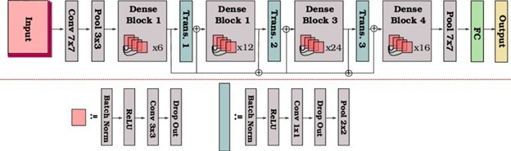

Figure 6. Example of DenseNet-121 model architecture

* + 1. ***ResNet-50 Model****:* Utilizing CNN to adjust the ResNet50 model is a typical method for identifying and categorizing brain tumors in MRI images. In this method, ResNet50 acts as a feature extractor after being pre-trained on the ImageNet dataset. Newly added fully connected layers replace the existing final layers for detecting brain tumors. Then, the model is fine-tuned using a set of MRI images, with weights being updated through backpropagation and stochastic gradient descent. Prepared MRI scans improve tumor visibil

ity, with the result being a likelihood distribution indicating whether a tumor is present or not. Utilizing ResNet50’s strong base features results in high accuracy for detecting and categorizing brain tumors. A model architecture called DenseNet-121 was depicted in Figure 7[17].

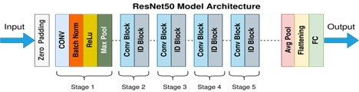

Figure 7. Example of ResNet50 model architecture

* + 1. ***MobileNetV2 Model****:* MobileNetV2 is a well-liked neural network created for mobile and embedded devices because of its small size and low number of parameters. Depth-wise separable convolutions are used to reduce parameters without sacrificing accuracy. The structure consists of consecutive convolutional layers with batch normalization and ReLU activation. Inspired by residual networks, its employs skip connections to enhance information flow. Unique features like linear bottlenecks and inverted residuals further boost performance. Residual connections between convolutional layers mitigate gradient issues, crucial for effective training. The model consists of a global average pooling layer to summarize features and a fully connected layer for making predictions. The architecture of Figure 8 represents a MobileNetV2 Model [18].

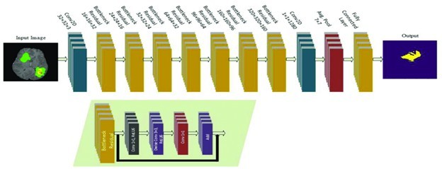

Figure 8. Example of MobileNetV2 model architecture

* + 1. ***VGG19 Model****:* VGG19, created by the University of Oxford, is famous for its simple yet profound convolutional neural network designs. With 19 layers—16 convolutional and

3 fully connected—it uses 3x3 filters and max-pooling to preserve spatial details in image processing. Although lacking key features like residual connections or inception modules, VGG19 effectively grasps intricate image functions. Utilizing SGD or Adam optimizers during backpropagation on extensive datasets like ImageNet, it produces sophisticated outcomes via SoftMax activation. Commonly used in transfer learning, VGG19 excels as a feature extractor in a variety of computer vision tasks such as image classification, object detection, and segmentation. The architecture of Figure 9 represents a VGG19 Model [19].

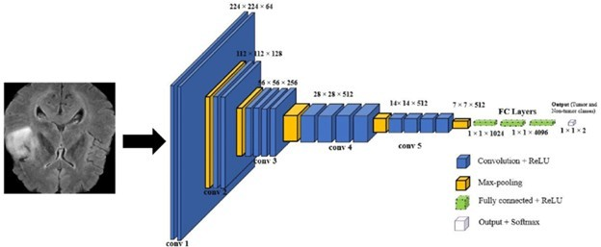

Figure 9. Example of VGG19 model architecture

* + 1. ***EfficientNet Model****:* The Dense EfficientNetB0 model merges DenseNet’s dense connectivity and EfficientNet’s efficient scaling, optimizing both performance and efficiency in deep learning tasks. It maximizes feature reuse and gradient flow across layers, enhancing training effectiveness. Through dynamically assessing the network’s depth, width, and resolution, it is able to achieve higher accuracy with less parameters than conventional models. The structure incorporates depth-wise and point-wise convolutions, batch normalization, ReLU activations, and skip connections to guarantee strong information flow and address training difficulties. Well-suited for mobile and embedded systems, Dense EfficientNetB0 utilizes SGD or Adam optimizers for training and excels in diverse applications like image classification, object detection, and segmentation, particularly in transfer learning scenarios. Figure 10 is a EfficientNetB0 Model architecture [20].

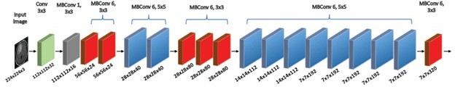

Figure 10. Example of EfficientNetB0 model architecture

# Results from experiments and their analysis

In this research, we utilized a brain tumor MRI dataset sourced from Kaggle, consisting of MRI images displaying brain tumors and accompanying segmentation masks. The dataset contains a total of 7023 MRI images. The dataset is divided into two subsets for training and testing purposes. 81.3% of the data is designated for training, while 18.7% is allocated for testing. We have used 8 different types of Models like:

TABLE II

**Avg. Accuracy of Precision, Recall, and F1-Score across all models**

|  |  |  |  |
| --- | --- | --- | --- |
| **Model Name** | **Precision** | **Recall** | **F1-Score** |
| VGG16 | 98.25% | 98% | 98% |
| CNN | 91% | 87.5% | 87.25% |
| DenseNet | 94.75% | 94.5% | 94.5% |
| ResNet50 | 81.5% | 81.75% | 81.25% |
| MobileNetV2 | 95.5% | 95% | 95.25% |
| VGG19 | 97.5% | 97.25% | 97.5% |
| EfficientNet | 7.75% | 25% | 11.75% |

TABLE III

**Results of Experiments**

|  |  |  |  |  |
| --- | --- | --- | --- | --- |
| **Model Name** | **Training** | | **Testing** | |
|  | **Accuracy** | **Loss** | **Accuracy** | **Loss** |
| VGG16 | 98.94% | 3.46% | 98.12% | 6.09% |
| CNN | 93.13% | 19.69% | 88.43% | 26.81% |
| DenseNet | 98.16% | 5.07% | 95% | 13.95% |
| ResNet50 | 84.86% | 37.47% | 82% | 43.69% |
| MobileNetV2 | 99.06% | 2.32% | 95.38% | 18.65% |
| VGG19 | 97.41% | 6.39% | 97.10% | 8.59% |
| EfficientNet | 28.49% | 138.52% | 30.93% | 138.41% |

* 1. ***VGG16*** *Model*

Figure 11 represent the Model training history with Accu- racy and loss values and training accuracy achieved 98.94% and 98.12% accuracy achieved on test dataset with the images of 1311.

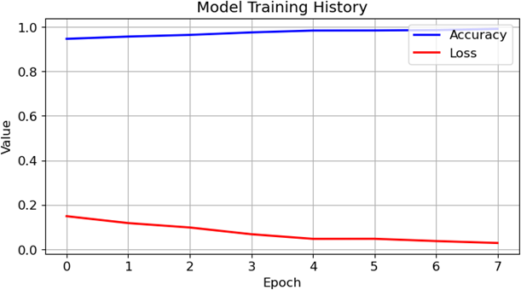

Figure 11. Model Training History of VGG16 Model

## Convolutional Neural Network Model

Figure 12 represent the Model training history with Accu- racy and loss values and training accuracy achieved 93.13% and 88.43% accuracy achieved on test dataset with the images of 1311.

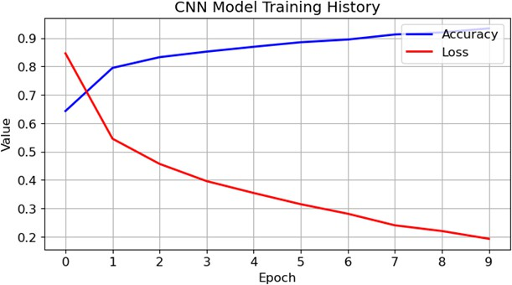

Figure 12. Model Training History of CNN Model

## DenseNet-121 Model

Figure 13 represent the Model training history with Accu- racy and loss values and training accuracy achieved 98.16% and 95% accuracy achieved on test dataset with the images of 1311.

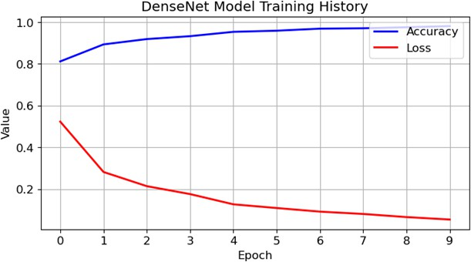

Figure 13. Model Training History of DenseNet-121 Model

## ResNet-50 Model

Figure 14 represent the Model training history with Accu- racy and loss values and training accuracy achieved 84.86% and 81.17% accuracy achieved on test dataset with the images of 1311.

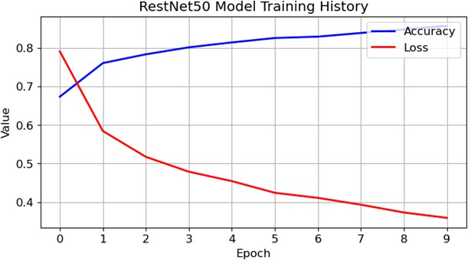

Figure 14. Model Training History of ResNet-50 Model

## MobileNetV2 Model

Figure 15 represent the Model training history with Accu- racy and loss values and training accuracy achieved 99.06% and 95.38% accuracy achieved on test dataset with the images of 1311.

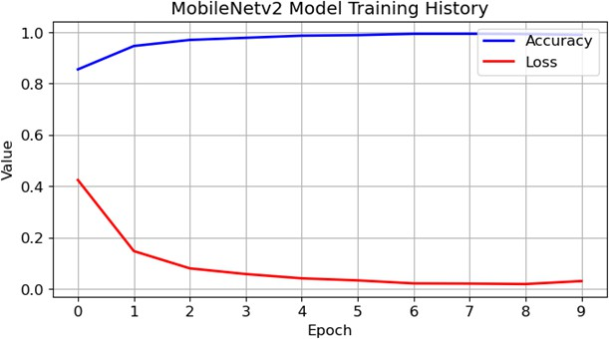

Figure 15. Model Training History of MobileNetV2 Model

## VGG19 Model

Figure 16 represent the Model training history with Accu- racy and loss values and training accuracy achieved 97.41% and 97.10% accuracy achieved on test dataset with the images of 1311.

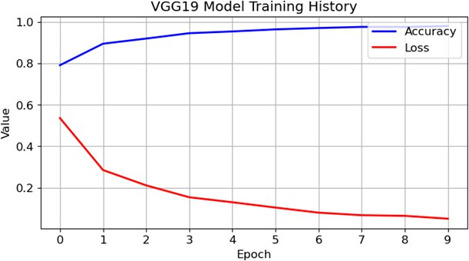

Figure 16. Model Training History of VGG19 Model

## EfficientNetB0 Model

Figure 17 represent the Model training history with Accu- racy and loss values and training accuracy achieved 28.49% and 30.91% accuracy achieved on test dataset with the images of 1311.



Figure 17. Model Training History of EfficientNetB0 Model

# Conclusion

This study explored how different deep learning models can categorize brain tumors using MRI scans. We tested seven models: VGG16, CNN, DenseNet-121, ResNet-50, MobileNetV2, VGG19, and EfficientNetB0. The dataset had over 7000 MRI images, sorted into four types of tumors. The findings showed that multiple models attained high accuracy when categorizing brain tumors in the testing dataset. Notably, VGG16, DenseNet-121, MobileNetV2, and VGG19 demonstrated exceptional performance. This suggests that deep learning has great potential for aiding in brain tumor detection. While ResNet-50 showed moderate accuracy, EfficientNetB0 required further investigation due to its lower performance.

In general, this research showcases the potential strengths of deep learning in classifying brain tumors. Future research can explore optimizing these models through hyperparameter tuning and potentially combining multiple models for enhanced accuracy. Additionally, incorporating data from other modalities alongside MRI scans could lead to even more robust tumor classification. It’s important to remember that these models require rigorous validation in clinical settings before real-world application.

# References

1. Khaliki, M.Z., Bas¸arslan, M.S. Brain tumor detection from images and comparison with transfer learning methods and 3-layer CNN. *Sci Rep* **2024**, *14*, 2664. https://doi.org/10.1038/s41598-024-52823-9.
2. Abd-Ellah, M.K.; Awad, A.I.; Khalaf, A.A.M.; Hamed, H.F.A. A review on brain tumor diagnosis from MRI images: Practical implications, key achievements, and lessons learned. *Magn. Reson. Imaging* **2019**, *61*, 300–318.
3. Sharma, A.K.; Nandal, A.; Dhaka, A.; Dixit, R. A survey on machine learning based brain retrieval algorithms in medical image analysis. *Health Technol.* **2020**, *10*, 1359–1373.
4. Ali, S.; Li, J.; Pei, Y.; Khurram, R.; Rehman, K.; Mahmood, T. A comprehensive survey on brain tumor diagnosis using deep learning and emerging hybrid techniques with multi-modal MR image. *Arch. Comput. Methods Eng.* **2022**, 1–26.
5. Arabahmadi, M.; Farahbakhsh, R.; Rezazadeh, J. Deep learning for smart Healthcare—A survey on brain tumor detection from medical imaging. *Sensors* **2022**, *22*, 1960.
6. Magadza, T.; Viriri, S. Deep learning for brain tumor segmentation: A survey of state-of-the-art. *J. Imaging* **2021**, *7*, 19.
7. Maqsood, S.; Damasevicius, R.; Shah, F.M. An efficient approach for the detection of brain tumor using fuzzy logic and U-NET CNN classification. In *International Conference on Computational Science and Its Applications*; Springer: Cham, Switzerland, **2021**; pp. 105–118.
8. Togac¸ar, M.; Ergen, B.; Co¨mert, Z. BrainMRNet: Brain tumor detection using magnetic resonance images with a novel convolutional neural network model. *Med. Hypotheses* **2020**, *134*, 109531.
9. Sajjad, M.; Khan, S.; Muhammad, K.; Wu, W.; Ullah, A.; Baik, S.W. multi-grade brain tumor classification using deep CNN with extensive data augmentation. *J. Comput. Sci.* **2019**, *30*, 174–182.
10. Prastawa, M.; Bullitt, E.; Ho, S.; Gerig, G. A brain tumor segmentation framework based on outlier detection. *Med. Image Anal.* **2004**, *8*, 275–283.
11. Swati, Z.N.K.; Zhao, Q.; Kabir, M.; Ali, F.; Ali, Z.; Ahmed, S.; Lu, J. Brain tumor classification for MR images using transfer learning and fine-tuning. *Comput. Med. Imaging Graph.* **2019**, *75*, 34–46.
12. Kumar, R.L.; Kakarla, J.; Isunuri, B.V.; Singh, M. Multi-class brain tumor classification using residual network and global average pooling. *Multimed. Tools Appl.* **2021**, *80*, 13429–13438.
13. Swati, Z.N.K.; Zhao, Q.; Kabir, M.; Ali, F.; Ali, Z.; Ahmed, S.; Lu, J. Brain tumor classification for MR images using transfer learning and fine-tuning. *Comput. Med. Imaging Graph.* **2019**, *75*, 34–46.
14. S. Karamehic´ and S. Jukic´, “Brain Tumor Detection and Classification Using VGG16 Deep Learning Algorithm and Python Imaging Library”, Bioengineering Studies, vol. 4, no. 2, pp. 1–13, Jul. 2024.
15. C. L. Choudhury, C. Mahanty, R. Kumar and B. K. Mishra,” Brain Tu- mor Detection and Classification Using Convolutional Neural Network and Deep Neural Network,” 2020 International Conference on Computer Science, Engineering and Applications (ICCSEA), Gunupur, India, 2020,

pp. 1-4, doi: 10.1109/ICCSEA49143.2020.9132874. keywords: Machine Learning; Brain Tumour; Biomedical Informatics; CNN,

1. Y. Li et al.,” Leveraging Sparse and Dense Features for Reliable State Estimation in Urban Environments,” *IEEE Robotics and Automation Letters (RAL)*, **2020**, *5*(2), 1324-1331, doi: 10.1109/LRA.2020.2967222

[Online]. Available: [https://www.researchgate.net/figure/A-schematic-](http://www.researchgate.net/figure/A-schematic-) illustration-of-the-DenseNet-121-architecture-82 fig5 334170752

(accessed on Jul 05, 2024).

1. *https://towardsdatascience.com/the-annotated-resnet-50-a6c536034758*.
2. Saeed, Muhammad; Ghulam, Ali; Bin, Wang; Almotiri, Sultan; Al Ghamdi, Mohammed; Nagra, Arfan; Masood, Khalid; Ulamin, Riaz. RMU-Net: A Novel Residual Mobile U-Net Model for Brain Tumor Seg- mentation from MR Images. *Electronics* **2021**, *10*, 1962. 10.3390/elec- tronics10161962.
3. MRI-based brain tumor detection using the fusion of histogram-oriented gradients and neural features - Scientific Figure on ResearchGate. Avail- able from: [https://www.researchgate.net/figure/Schematic-diagram-of-](http://www.researchgate.net/figure/Schematic-diagram-of-) VGG19-for-our-experimental-set-up fig2 348483474 [accessed 9 Jul,

2024]

1. H. H. Sultan, N. M. Salem and W. Al-Atabany,” Multi-Classification of Brain Tumor Images Using Deep Neural Network,” in IEEE Access, vol. 7, pp. 69215-69225, 2019, doi: 10.1109/ACCESS.2019.2919122.

keywords: Tumors; Feature extraction; Cancer; Task analysis; Magnetic

resonance imaging; Convolutional neural networks; Training; Brain tumor; convolutional neural network; data augmentation; deep learning; MRI,